The Baseline Action and Momentum (BAM) Program  
Survey Results

# Survey Respondents

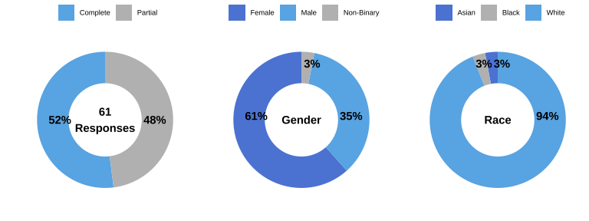

The BAM survey received **61 responses**. Sixty-one percent of respondents are female, 35% of respondents are male, and 3% are **non-binary**. The majority (94%) of respondents are white, and 3% **Asian** and 3% **Black**.

# BAM Activities Engagement

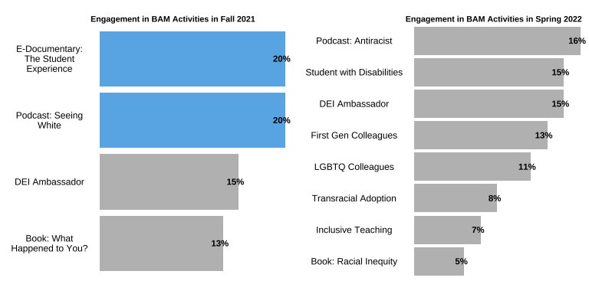

Most of BAM activities received around **15%** of respondents’ participation. The E-documentary on student experiences and podcast on seeing white in Fall 2021 received the most participation, with 20% of respondents engaged in them. Engagement in BAM activities seem to decrease from Fall 2021 to Spring 2022. Several BAM sessions in Spring 2022 (Book on racial inequity, Inclusive teaching, and Transracial adoption) received less than 10% of respondents’ participation.

From respondents’ comments, we found that participants liked the variety of **topics and formats** of presentations. Meanwhile, respondents hoped to see more topics covered in the BAM events. A respondent suggested to expand the race-centered diversity discussion to also include **socioeconomic classes**, such as how diversity also exist within the White ethnic group. Another respondent proposed BAM events around how to properly deal with people with **different views**. A respondent also requested a BAM session focusing on **practical examples and models** of teaching DEI topics in class.

# BAM Activities Benefits

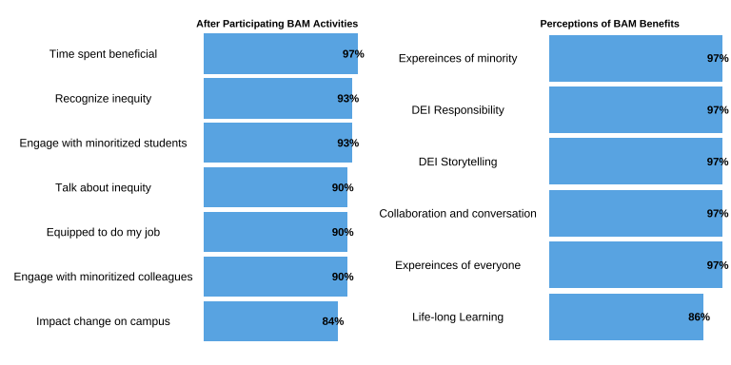

Respondents overall believe attending BAM activities are **beneficial**. 97% of respondents believe BAM program could improve experiences of minority students and everyone, generate shared responsibility and storytelling about DEI, facilitate collaborations and conversations across units. Over 90% respondents felt they are better able to recognize and talk about inequity, and engage with minority students and collagues. 84% of respondents felt they can impact change on campus. 86% of respondents believe BAM program could extend life-long learning.

In the qualitative comments, many participants further indicated their growth in becoming more conscience of assumptions and **word choices**. Respondents reflected that they are more capable of understanding reactions to words and how **feeling** can influence one’s cognitive learning. A few participants also mentioned that they are more comfortable discussing **DEI in classroom** and are more willing to learn from student experiences. A participant also appreciated that the BAM program helped reinforce the importance and understanding of DEI in their department and in general.

# Future Participation

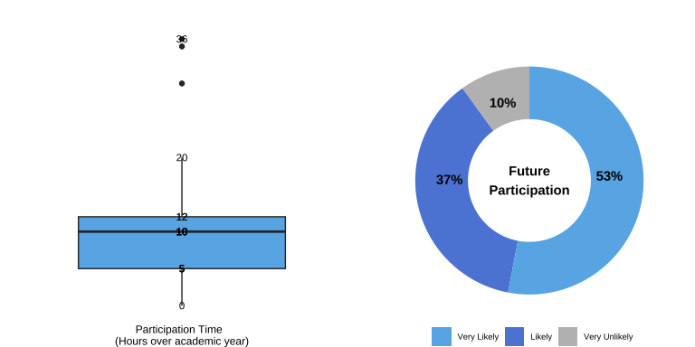

Most respondents spent **10 hours** (over the academic year) on all the BAM events. The maximum time spent is 36 hours. There are **90%** of respondents indicated they are likely or very likely to participate in future BAM events.

From comments, a respondent indicated inconvenience of scheduling each BAM events at the same time. The respondent suggested that different BAM events could happen at **different times** and days of the week, which may increase the possibilities of more people to be able to attend. The respondent also requested BAM events to have both in-person and **online recorded** versions, so that people can complete BAM program with more flexibility. Additionally, a respondent recommended that a BAM **event calendar** could be helpful for participants to plan overall.

To increase BAM events participation, a respondent suggested that BAM events can be promoted more strategically, such as **advertising** BAM events at different gatherings and meetings like the faculty meetings and welcome back gathering. A few respondents also indicated that they hope to receive **more reminders** of the BAM events, and **more reach-out** from BAM ambassadors regarding DEI opportunities.

# Summary

* Respondents appreciated the variety of **topics and formats** of BAM events. A few more BAM event **topics t**hat respondents requested include: multi-faceted diversity beyond race (i.e. socio-economic classes), deal with different views, teaching DEI topics.
* Over 97% of respondents perceived BAM program as **beneficial.** The benefits are concentrated on improved inclusive communication skills, openness to learn from student experiences, and understandings of how students’ feeling can affect learning.
* Engagement of BAM activities in Fall 2021 and Spring 2022 range from 5% to 20% from survey respondents. To **increase participation**, respondents suggested that BAM events could happen at varied time with online recordings available. The BAM program may have a event calendar, which can be promoted early in the semester at different meetings. Respondents also requested more reminders of BAM events and communications about other relevant opportunities.